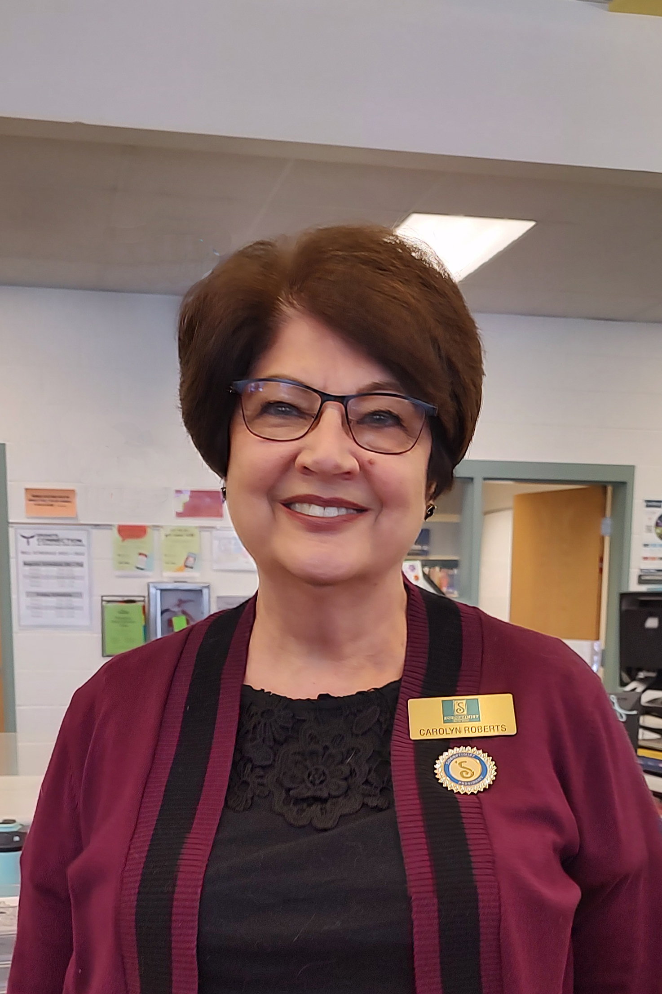
Volume 1, Issue 10
Salty Soroptimist News
June, 2022
President’s Message
My presidential year is swiftly coming to a close. We will publish a final newsletter in July in which I will officially bid you farewell.

In the meantime, we still have many things to accomplish. I am thrilled that our club will be able to host the fabulous fundraising Garden Party June 23. The fundraising committee has been busy working behind the scenes to plan an unforgettable event. This is a great opportunity to get out for the evening, enjoy some fresh air, connect with friends, and just have a good time. Please plan to attend and bring as many guests as you can.
In this Issue…

Happy birthday, georgia
presnell 2
garden party fundraiser 3
silent auction item
needed 3
membership renewal 4
new membership pin 4
SI SLC supports ukraine 5
Upcoming Events 6
Happy birthday! 6
dream big campaign 6

I am equally excited to be hosting a birthday party for our 103-year-old member, Georgia Presnell on June 7. Details of the party appear later in this newsletter.

We will wrap up a successful year of service by delivering 30 buckets filled with cleaning supplies and hygiene kits to People Helping People. People Helping People is a local non-profit employment program dedicated to helping low-income women and single moms reach their full potential in the workplace. PHP helps families break the cycle of poverty by teaching low-income women how to earn a living wage. Their mission closely aligns with ours.

I’m looking forward to June because of the potential we have to do good and make a difference in our community. I’m also looking forward to this month because I will get an opportunity to see all of you.

Carolyn Roberts, President, SI of Salt Lake

Soroptimist International of Salt Lake City
Chartered November 12, 1931

Happy Birthday, Georgia Presnell!

By Carolyn Roberts

Georgia Presnell of Orem Utah turns 103 years old on June 7th. Soroptimist International of Salt Lake City along with her family will host a surprise birthday party in her honor.

Georgia joined Soroptimist 48 years ago in Sacramento California and has “lifetime” status with Soroptimist International of the Americas. “Life members” must have received that designation prior to 2001 and still be in good standing. Currently less than 200 life members remain in SIA. Georgia has retained her membership with SI Sacramento but is also considered an honorary member of the Salt Lake Club. It is like having dual citizenship and this arrangement has been sanctioned by SIA.

Georgia Burt was born June 7, 1919, in Salt Lake City shortly after the end of World War I. She had one sister and one brother who passed away at age 2 of the Spanish flu. She married her high school sweetheart, Frank Presnell. At the time of his passing, they had been married for 60 years. Frank served in the military and fought in the Second World War at the Battle of the Bulge. They made their home in Sacramento, CA. Georgia has two sons, Greg Presnell of Orem, UT and Burt Presnell of Sacramento, CA. She has two grandchildren.

Throughout her life Georgia has been energetic and industrious. She enjoyed a successful career working in real estate. She served as Vice President of Tahoe Pacific Escrow Company. She later worked at American River Bank retiring at age 90. Last October at the age of 102 Georgia sold her home in Sacramento and moved to Orem Utah where she lives unassisted at Treeo Retirement Community.

Georgia loves people and being active. She has a charismatic personality. To know her is to love her. She is in amazingly good health. She gets up early, never naps and only eats two meals a day: breakfast and dinner. She laments that the exercise classes they have at the retirement center are not strenuous enough for her, so she goes back to her apartment and exercises some more to complete her exercise routine. She is meticulous about her appearance, always dressing elegantly with full makeup, painted nails, jewelry, and wearing high heels.

She attributes her long life to her many years of service to others. Georgia volunteered for Easter Seals for 17 years and served on the board of directors. She volunteered at the March of Dimes for 9 years. She has worked with The Sacramento Children’s Home, Make a Wish, and Shriners. Soroptimist is the organization that is most dear to her heart and to which she has given the most service.

When asked how she stays so young, she responds good genes, clean living, being active by doing the things you can do, and, of course, wearing high heels.

Garden Party Fundraiser

One of the amazing benefits of being a Soroptimist member is being able to socialize and network while supporting our programs through raising money. Our Garden Party on June 23 provides an opportunity to do all these things, socialize, support our club, and raise funds for our programs.

Our success depends on the participation of all our club members.

We need you –
- To attend the event
- To promote the event to friends and associates via social media, email, mailed invitations and word of mouth
- To obtain silent auction items from businesses or friends (This is how we make our money)
- To assist in the production of the event
Set-up
Decorate
Serve food
Clean-up

How you benefit –
- Beautiful atmosphere
- Dinner
- Live music
- Drinks – We will be serving wine for a $5 suggested donation

Silent Auction Items Needed

Our fundraiser will be here in less than a month! You know what that means- we need your help to make it a smashing success. I hope you have all sent out your invites and got your own tickets purchased and volunteered to help in some way.

I am working on the Silent Auction and asking you to PRETTY PLEASE WITH SUGAR ON TOP get at least one silent auction item as soon as you can. I’d like to have everything in by June 15th.
Consider contacting businesses, restaurants, etc. that you frequent. Maybe friends or family that work somewhere that could offer something. Or create your own item or gift basket (don’t wrap them in cellophane.) We’d like to raise as much money as possible to fund our programs so Think Big!
Please drop items off at my house- 678 Downing St in Midvale or let me know and I can pick up from you. Also provide the description, value and who donated.

Let’s jump right on this so you can cross it off your list- we can make it happen!! Go Soroptimists!

Jan Crane
Call me with any questions: 801-870-1222

MEMBERSHIP RENEWAL for 2022-2023
Due by June 20*

It is time to renew your membership for the 2022-2023 club year. Your membership in the club is vital for us to continue to help woman and girls in our community. We need each one of you!

Membership dues remain the same this year, $155 for a full year if paid in cash. Please let us know if you have any questions or any special needs. Our club success is because of wonderful members like you!

New Style Membership Pin Available

Replace your old membership pin with the new style. Treasurer Loretta Peterson has some available for purchase at $15 each. They will be available at our fundraiser on June 23 or contact her directly. Get yours today.

SI of Salt Lake Supports Ukraine

Soroptimist of Salt Lake City members donated $305 to a fund we set up for Ukraine. The club added $175 for a total of $480. The donations were made through the Soroptimist International of Europe website to their disaster relief fund specifically for the war in Ukraine effort.

Upcoming Events

Jun 1  Jun 1  Jun 7  Jun 23  Jun 30  Jul 1  Jul 22-23 | - Board Meeting 5:30 pm  - Newsletter Deadline  - Georgia Presnell 103rd birthday party  - Spring Garden Party Fundraiser  - Membership Dues Deadline  - Celebrating Success Deadline  - SIA Virtual Convention
Happy Birthday
aro

Georgia Presnell – June 7
Georgia's 100th Birthday interview

Send birthday wishes to Georgia at
Treeo Senior Living
250 East Center Street, Apt. 137
Orem, UT 84057

Soroptimists believe in the power of dreaming big. That’s why we’ve set a goal through our Dream Big Campaign of investing in the dreams of half a million women and girls.
That’s four times the number of women and girls we currently reach. It’s a big, audacious goal. But no more audacious than the courage and resolve of the women and girls our Dream Programs will impact.

